 | ABES Engineering College, Ghaziabad  Department of Computer Science & Engineering
Session: 2016-17 Student Name: Abhishek Chopra Uni. Roll No. 1403210009
Subject Code: NCS-502 Subject Name: DBMS Semester: Vth/A

Assignment 1: SQL Queries using Various Operators

A. Queries based on Conditional Retrieval of Rows
1. List department names and location from the department table.
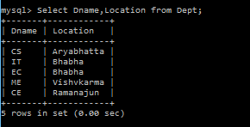

2. List the employees belonging to the department 20.
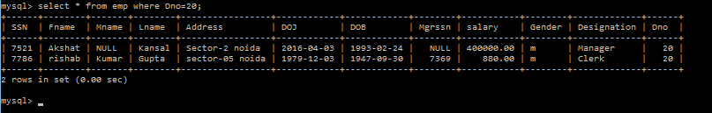

3. List the name and salary of the employees whose salary is more than 1000.
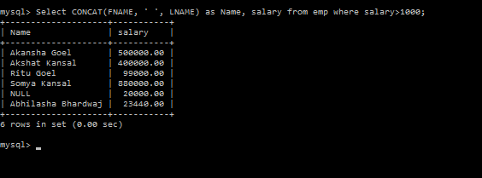

4. List the employee number and name of managers.

5. List the name of clerks working in the department 20.
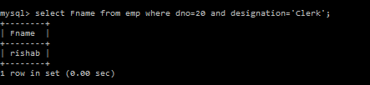
6. List the names of analysts and salesmen.
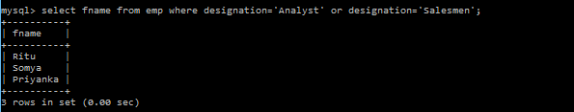
7. List the details of the employees who have joined before the end of September 1981.
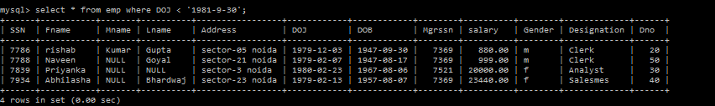

8. List the names of employees who are not managers.
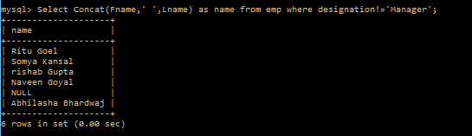

B. Special Operators IN and BETWEEN
1. List the name of the employee whose employee numbers are 7369,7521,7839,7934, 7788.
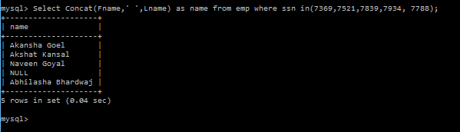

2. List the employee details not belonging to the department 10,30 and 40.
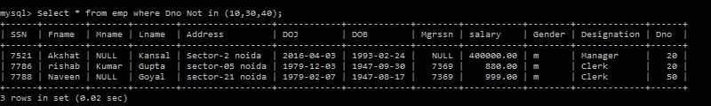
3. List the employee name and salary , whose salary is between 500 and 2000.
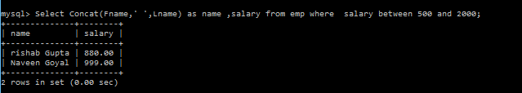
4. List employee names, who have joined before 30th june 81 and after December 81.
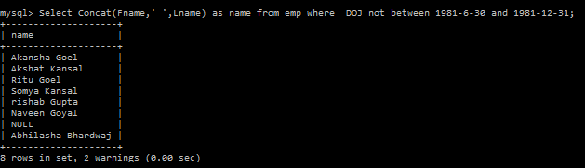

C. DISTINCT Clause with SELECT
1. List the different jobs (designations) available in the emp table.
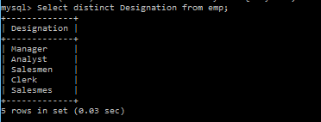

D. Working with NULL Values
1. List the employee names, who are not eligible for commission.
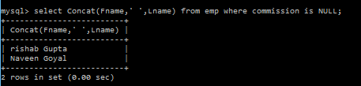
2. List the name of the employees and designation (job) of the employee, who does not report to anybody (manager is NULL).
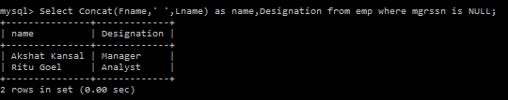
3. List the employees not assigned to any department.
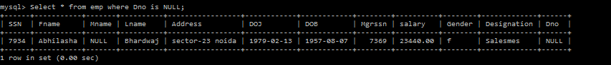
4. List the employees who are eligible for commission.
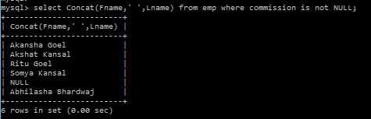
5. List the details of employees , whose salary is greater than 2000 and commission is NULL.
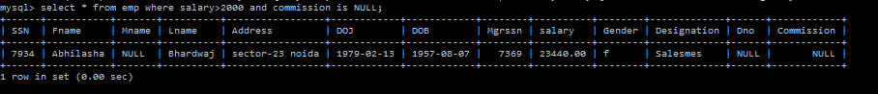

E. Matching Pattern with Column
1. List the employees whose names start with an “S”.

2. List the employees names ending with an “a”.
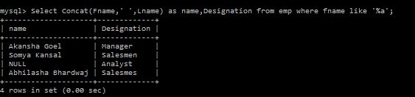
3. List the names of employees whose names have exactly 5 Characters.
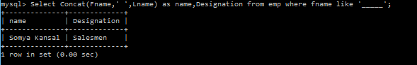
4. List the employee names having “I” as the second character.
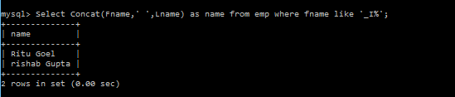

F. Using Expression with Column
5. List the name , salary and PF amount of all the employees( PF is calculated as 10% of salary).
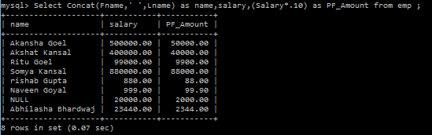
6. List the names of employees , who are more than 2 years old in the organization.
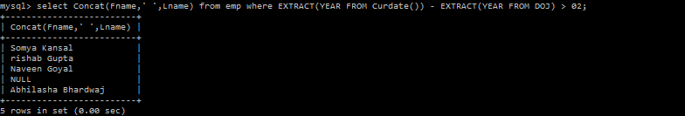

G. Ordering the Results of a query

1.List the empno,ename,sal in ascending order of salary.
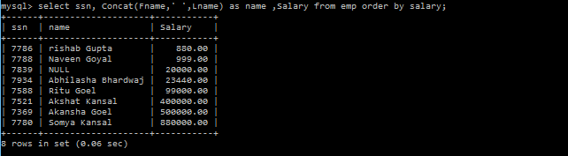

2. List the employee name and hiredate in descending order of Hiredate.
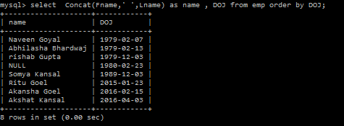

3. List the employee name, salary , job and department No. in ascending order of Department No. in ascending order of Department No and then on descending descending order of salary.
